Name: __________________________________________________________ Block: ____________
MS. YEGANEGI’S CHEAT SHEET FOR ONLINE RESEARCH
Question 1: How often do you get information from the Internet? How much of it do you believe?
Question 2: How reliable do you think Internet information is? How does it compare to information from books?
So you have a topic to research and write about? How are you going to start? This is my guide to help you figure out the best way to get the information you need.
1) Always remember – not everything on the Internet is true…
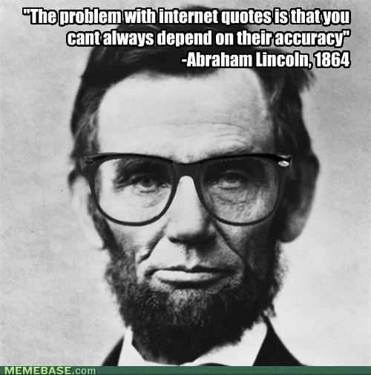
2) Only use CREDIBLE sources. The best way to determine whether or not a source is credible is by studying the name of the website.
HOW TO DETERMINE CREDIBILITY OF ONLINE SOURCES:
A. Look at the endings. Academic or trustworthy websites often end in: .edu .org .gov
B. Figure out which company is running the website. Start with major news sites, such as CNN, The New York Times, The Wall Street Journal, USA Today, etc.
C. Any informational sites such as Encyclopedia Britannica, World Book, The Library of Congress, etc. are trustworthy.
D. Avoid ANYTHING and EVERYTHING that is a wiki (i.e. WIKIPEDIA). Wiki means anyone can add/change/delete information about any topic, which means it could be the person sitting next to you pretending to be an expert on a topic they know nothing about.
E. Follow these general steps to determine whether or not a source is credible -
1. Cross-check the information and see if you can find it in more than one place.

2. Find the copyright (usually at the bottom of the page) and know when it was last updated.

3. Find out who the author/creator is, and preferably, the author's credentials.
What is the author’s education level? Does he or she have a degree? From what school? In what subject? How much does the author know about the topic?
4. Look at the domain. Is it a .org site or a .com site, with ads, for example?
5. Does the layout and format present the information in a professional manner?

6. Is the site easy to navigate and user friendly? If not, it might not be the best place for gathering information.

7. Is there any evidence of bias on the site?

Does the author have a neutral perspective on the site’s subject matter, or
is he or she trying to promote a particular viewpoint?
3) Sometimes the easiest way to find the right information is to search for the question you’re trying to answer. For example, if you’re researching the types of challenges that an immigrant faces when they come to the USA, you could literally search for, “What challenges do immigrants face when they come to the USA?”
However, make sure you cover yourself by doing the following:
- You must use different search engines and strategies, and keep track of how the search “goes” using the various resources and methods.
- Once you find an answer that you are confident in, do another search to verify the information.
- When you are finished, evaluate the reliability of all of the Internet resources that you used.
- Prepare to tell the story of your search, including what worked and what didn’t, anything surprising that happened, things that would be good for other searchers to know, “lessons learned,” etc.

4) Once you have a broad understanding of your question/topic, narrow down your search to get more details. Just keep making sure you follow all the steps above.
5) CITE, CITE, CITE!
Plagiarize: : to use the words or ideas of another person as if they were your own words or ideas; to steal and pass off (the ideas or words of another) as one's own; use (another's production) without crediting the source
From our syllabus: Cheating is considered a serious matter. Consequences include a zero on the assignment, a grade of U in conduct, a parent notification, an administrative referral, and exclusion from all extra credit opportunities. PLAGIARISM is CHEATING!!
CITING means that you give credit to someone else for their words/thoughts by placing quotation marks around what they said. If it wasn’t your original thought or very common knowledge, you should cite it.
*See the next page for instructions on how to cite an online source in MLA style.

MLA Style Citations:
In-Text: For citations included in your writing, you need to include some information about where you got the information/quote. Usually this is the author’s name, the article’s or website’s title, or at the minimum, the name of the company/organization running the website. Most websites don’t have page numbers, and you shouldn’t make one up. If there are labeled/numbered paragraphs, sections, etc. you can use that number instead. Otherwise just make sure you have a name in your sentence.
Here are some of the best and most common ways you can write in-text citations:
- According to author’s name , ________________________________ (page number, if you have one).
- In the article “Name the article here” , author’s name states/explains/etc. _________________________________________ (page number, if you have one).
- According to a study completed by organization/company’s name , ____________________________________________________.
Works Cited Page: You will create a Works Cited list where you reference all the sources you used. Use, in this order, as many of these items as are relevant and useful for clearly identifying the source document. The list is long not so that you will include all of it in every reference, but because Web page content and format vary so widely.
1. Author last name, then first name.
2. Title of the article in quotation marks.
3. Web site name, italicized. (Underlined if you write it by hand.)
4. Edition or version number.
5. Web site owner or sponsor if available.
6. Date of publication (DD MM YYYY as in 15 June 2009). If a publication date is not available, use n.d. for "no date."
7. The word Web and a period to indicate the publication medium.
8. The date you accessed the site and a period.
Note that often you will not have all of these items. The site name will be available, but the Web site owner or sponsor will be the same or not known. Similarly, there may not be a version or edition number.
Examples:
One author: Smith, John. "Obama inaugurated as President." CNN.com. 21 Jan. 2009. Web. 1 Feb. 2009.
No author listed: "Obama inaugurated as President." CNN.com. Cable News Network, 21 Jan. 2009. Web. 1 Feb. 2009.
IMPORTANT:
There are tons of automatic citation websites out there now. If you want some help, try www.easybib.com (just make sure you choose MLA).

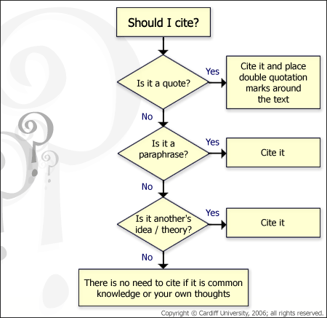

WHAT INFORMATION IS NOT CITED
1. Well-known sayings do not require a citation.
A stitch in time saves nine.

2. Commonly known facts do not require a citation.
Atlanta is the capital of Georgia.
William Shakespeare wrote Romeo and Juliet.

