Name: ______________________________________ Date: ____________ Block: _____
Symbol (Symbolism): symbol (sim-bol): a symbol is a word or object that stands for another word or object. The object or word can be seen with the eye or not visible.
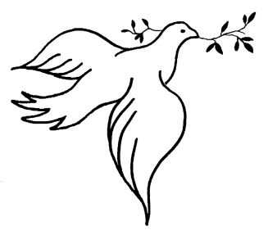
What do the following images represent or SYMBOLIZE?

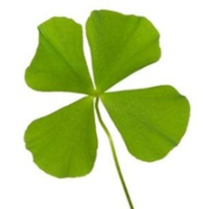
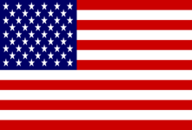

Hopefully, what you’re realizing is that many objects in the world represent or SYMBOLIZE a bigger idea or more important concept.
NOW: To brainstorm for the activity we are working on today, you need to come up with some symbols to represent who you are. Just fill in the chart below.
 | Your Answer | Symbol that can represent your answer
One word to describe your personality |  | Color Symbol:
Another word to describe your personality: |  | Color Symbol:
Something you care about
Something you care about
A hobby you have
A hobby you have
A goal you have for your life
A goal you have for your life
The most important thing in our life

