100 years of Iranian history, explained in 11 women's hairstyles
Updated by Amanda Taub on February 21, 2015, 10:00 a.m. ET @amandataub
Women's fashion has long been a political issue in Iran, initially as a public way of enforcing secular political values, and then as a public way of enforcing religious ones. Because each style in the video is so specific — and because the model manages to convey some sense of each character with a few well-placed facial expressions — it offers a quick visual tour through women's changing roles, rights, and options in Iranian history.
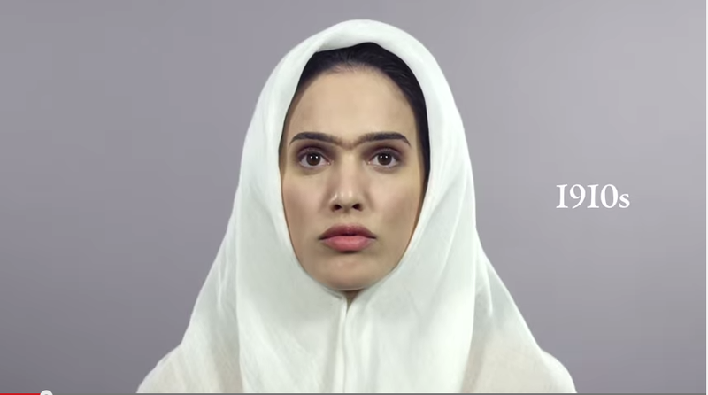
This woman dresses modestly in a headscarf, a sign that she is a devout Muslim.
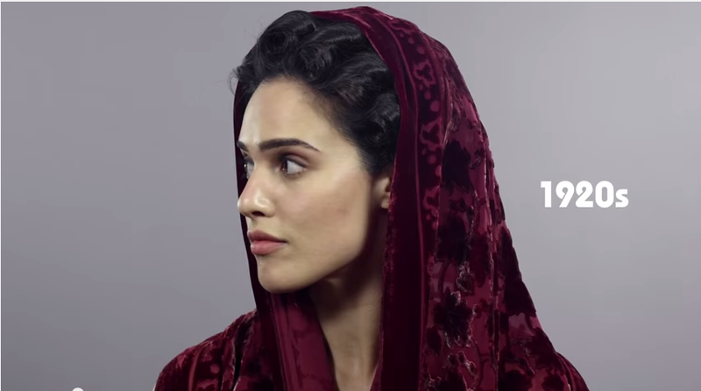
Her style grows more ornate in the 1920s, when the secular regime of Reza Shah came to power: she still covers her hair, but only partially, with loose shawl over an elaborately curled style.
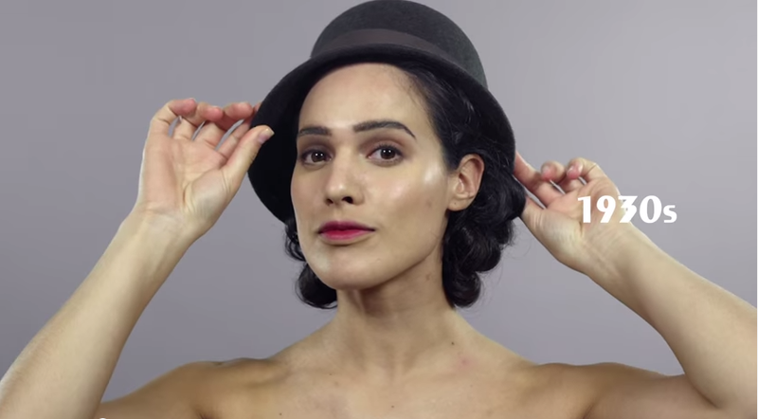
Then, in the 1930s, her veil is replaced with a hat over a pinned-up chignon — perhaps a reference to Reza Shah's 1936 decree that banned women from veiling themselves in public. He saw the hijab, chador, and other types of religious coverings as incompatible with his modern ambitions for the country, and refused to allow women to wear them publicly, regardless of their personal religious beliefs.
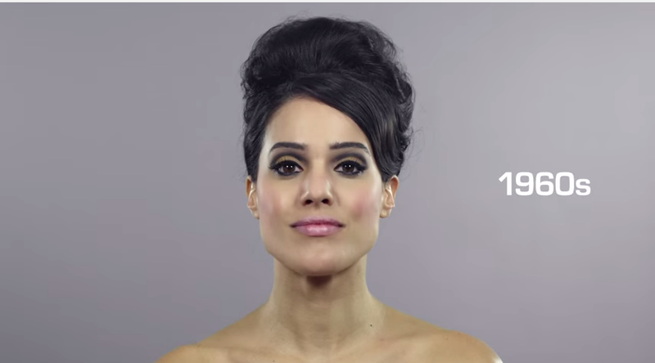
In later decades, during the period when Iran was ruled by Mohammed Reza Pahlavi, Reza Shah's son, the model wears her hair uncovered, and sports glamorous styles reminiscent of movie stars of the era. Those decades brought new rights for Iranian women. In the 1960s Iranian women won the right to vote and run for office, and family laws were reformed to give them greater protections in divorce and custody disputes.
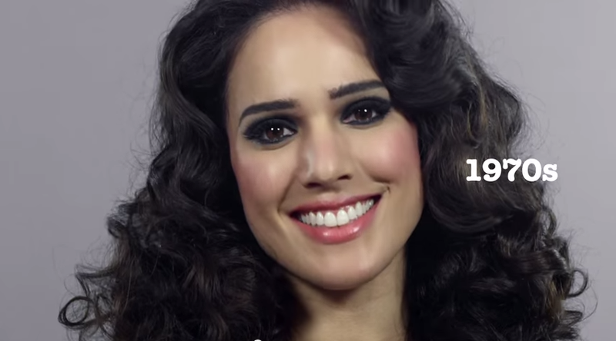
By the 1970s, they were serving in parliament and local councils in large numbers.
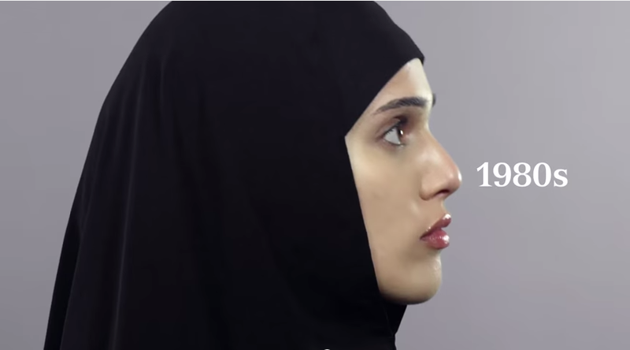
But the Shah's regime was a brutal autocracy. Its secret police, the SAVAK, used torture and arbitrary arrests to crush dissent. Dissatisfaction with the Shah's regime — including its enforcement of secular policies — eventually led to his overthrow in the Iranian revolution of 1979. Women were active participants in the revolution, and a number of them embraced the religious fundamentalism of the new government. The new, Islamic regime that followed required women to wear the hijab, with no hair showing.
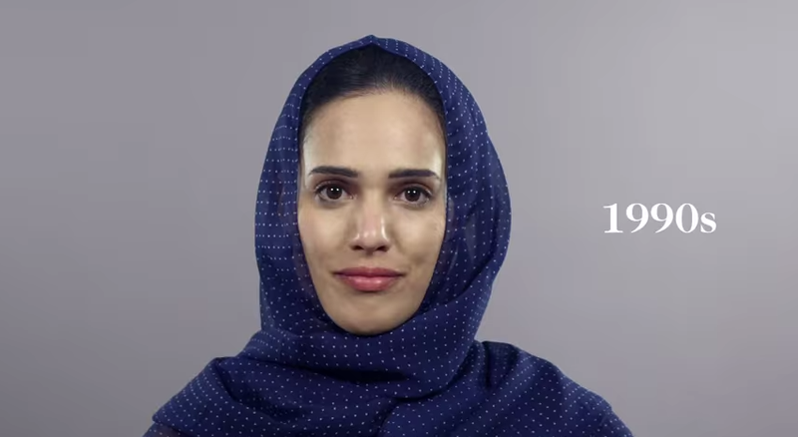
In the 1990s, during the presidencies of the pragmatic Akbar Hashemi Rafsanjani and moderate reformist Mohammed Khatami, the model wears a more relaxed religious style with more of her hair showing under a looser scarf.
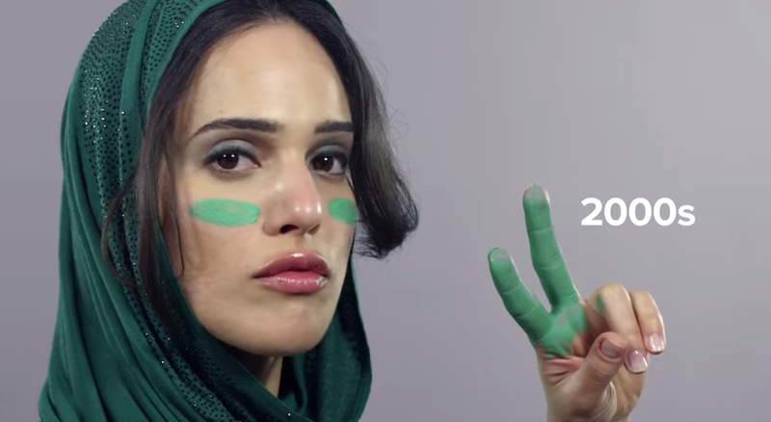
In the 2000s, she becomes a member of the Green Movement, an ultimately unsuccessful pro-democracy movement 2009 and 2010.
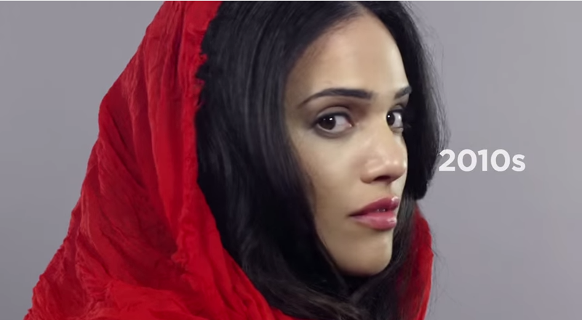
And then, finally, an Iranian woman of today, with an even looser headscarf showing much of a full, elaborately curled hairstyle. In recent years Iranian women have been pushing the limits of Islamic dress requirements, including by wearing their scarves far back on their heads with much of their hair showing, and by replacing coat-like black chadors with brighter and tighter clothing.

