What is a revolution?
A fundamental change in power or organizational structures that takes place in a relatively short period of time.
Perhaps most often, the word "revolution" is used to denote a change in socio-political institutions. There are two primary definitions of this type of revolution:
1) Any and all instances in which a state or a political regime is overthrown and thereby transformed by a popular movement in an irregular, extraconstitutional and/or violent fashion
2) Regime change, but also more or less rapid and fundamental social, economic and/or cultural change, during or soon after the struggle for state power.
Most revolutions have one shared purpose: to change the political authority and their actions.
The Iranian Revolution
The Shah
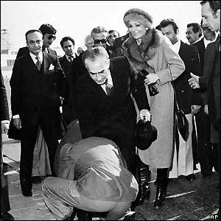
Before the revolution Iran was ruled by Shah Reza Pahlavi. Power was clustered among a close network of the Shah's relations and friends.
During the 1970s the gap between Iran's rich and poor grew.
Distrust of the Shah's economic policy and resentment of his autocratic style fuelled dissent against his regime.

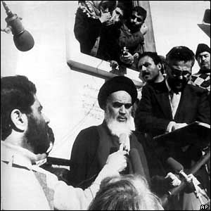

Voice of opposition
Opposition voices rallied round Ayatollah Ruhollah Khomeini, a shia cleric living in exile in Paris.

Promising social and economic reform, the ayatollah prescribed a return to traditional religious values, which struck a chord with many Iranians.

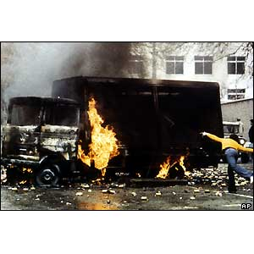
Gathering storm
As the 1970s drew to a close, a series of large-scale, increasingly violent anti-Shah protests swept Iran.

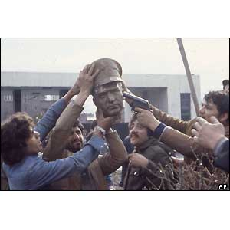
Instability, including a wave of general strikes, continued throughout the year, crippling the country's economy.

Fallen leader
In January 1979, the Shah left Tehran for an "extended vacation".
He was never to return.
All over Iran statues of the Shah were torn down by Khomeini supporters.
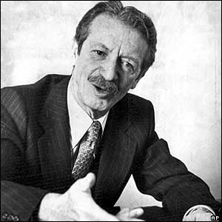
Final straw
In his final act before fleeing, the Shah appointed Prime Minister Shahpur Bakhtiar as head of a council to run the country in his absence.
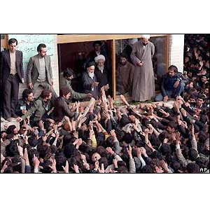
Mr Bakhtiar tried to stave off the growing tide of opposition. He refused to allow Ayatollah Khomeini to form a new government.
Violence erupts
On 1 February 1979, Ayatollah Khomeini made a dramatic return from exile.
Political and social instability increased. Street battles raged in towns and provinces between pro-Khomeini demonstrators and police and security officers, and supporters of the imperial regime.

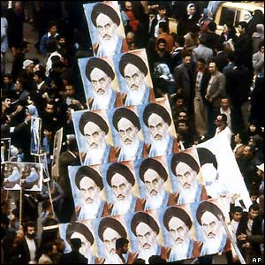
The revolution
On the 11 February, tanks rumbled through the streets of Tehran amid rumours of an impending military coup.
However as the day wore on it became apparent that the army had little appetite for seizing power.
Revolutionaries stormed Tehran's main radio station and declared: "This is the voice of the revolution of the Iranian people!"

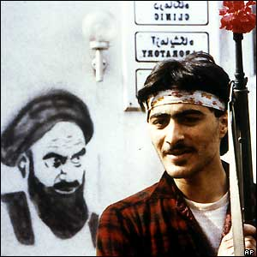
New era begins
Prime Minister Bakhtiar resigned. Two months later Ayatollah Khomeini won a landslide victory in a national referendum.

He declared an Islamic republic, and was appointed Iran's political and religious leader for life.

IMPACT OF THE IRANIAN REVOLUTION
Views differ on the impact of the revolution. For some it was "the most significant, hopeful and profound event in the entirety of contemporary Islamic history," while other Iranians believe that the revolution was a time when "for a few years we all lost our minds,” and which "promised us heaven, but... created a hell on earth." It is definitely the event that created the Iran we know today – Islamic fundamentalism (requiring all citizens to live by Islamic law), issues with the American government, and lack of social and political freedom (not to mention religious freedom).

