**SETTING UP YOUR ACCOUNT**

1) Go to [www.glogster.com/login](http://www.glogster.com/login)

2) Create a new account

3) Please make your nickname your two names combined, so I can easily recognize it: i.e. Yeganegi_Sims

4) Enter the rest of your information. *One of you needs to have an email address to finalize your account. Let me know if you need help with this.

5) Once you authorize your account, you are ready to start.

**CREATING YOUR GLOG**

When you open a new Glog, you will see an example.

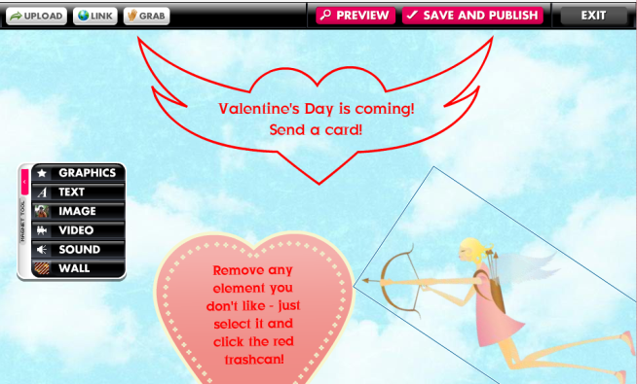

To remove any elements you don’t want to use in your Glog, click on element and then click on the **RED TRASH CAN.**

At the top of the Glog screen, there will be a rectangular box labeled **“Glog name”** next to it. Click in the box, delete the default name and give your Glog a unique meaningful name.



**Backgrounds:** To add a background, select “Wall” from the toolbox. (The toolbox may be repositioned on the page as needed by sliding it.) The **Glog Wall tab** places the background on the actual glog. The **Page Wall tab** changes the color or pattern of the border outside of the glog wall.



**Graphics:** Use the graphics button to add decorative graphics provided by Glogster. Search through the collections, click once on your selection. It will appear by itself in the preview area above the USE IT button. Click on **USE IT!** to add the graphic to your Glog.

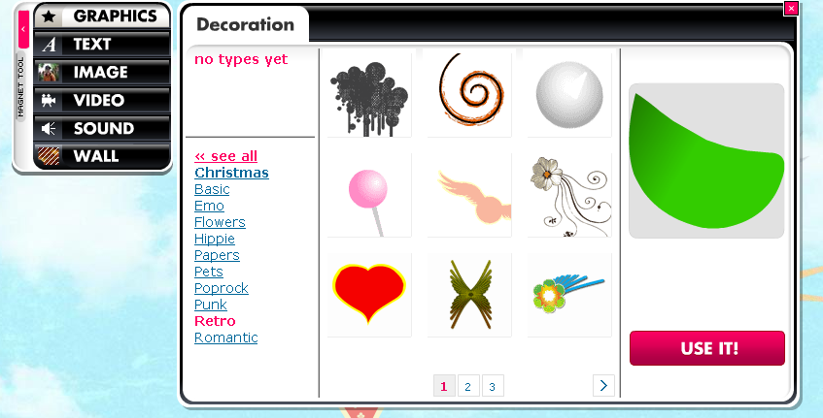

**Text:** To add text, select “**TEXT**” from the toolbar. Choose a textbox (default), a title box, bubbles or stickers for your text. A wide variety of text boxes are available from each category. Select the textbox you want and click “**USE IT**.” The textbox will appear on your screen.

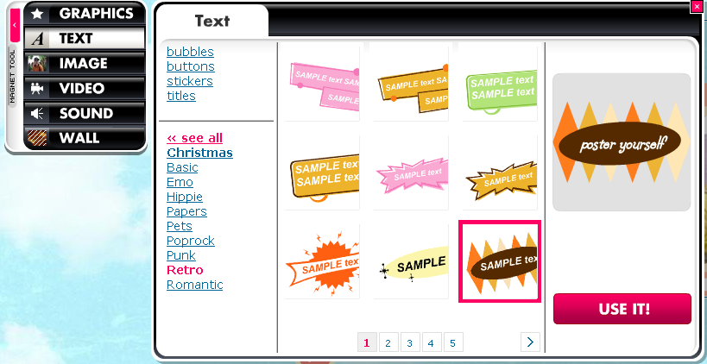

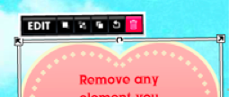 editbarglog

Takes you to the edit menu.

1. Click “**Edit**” above the textbox to type text. The menu will change to the edit menu.
2. Click the “**Ab1**” button on the menu to change the font size and style, or to bold, center, or add italics. The color chart button will allow you to change the font color. Color effects may be changed by the **fx** button.

**TIP:** To create a rectangular textbox, as in a title banner, choose “**TITLES**.” For a regular (square) textbox, use the default textbox. Change the size of a textbox, by pulling the sides. It maintains its shape but grows. To create text with no box or frame around it, choose **“Basic Text,” “Basic bubble” or “Basic Title.” Adjust the font size from the TEXT EDIT box so that all text is visible or a scroll bar will appear.**

**Images:** Use the “Image” button from the toolbox to upload photos, pictures, sound files or video files. Click “Upload” and browse to the files on your computer. Select the image and click “OPEN.” Your photos will be added to your Glogster library. Hold down the SHIFT key to select multiple images.

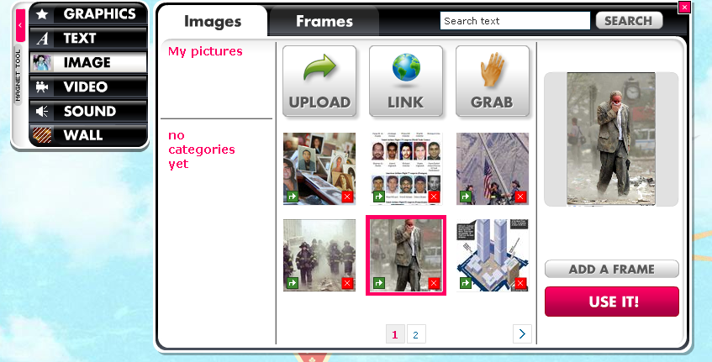

To add images to the Glog, select your image, and click “USE IT!” Frame your photo by clicking the “**ADD A FRAME**” button. Your image is always added to the bottom of the screen. Locate it and drag it to the desired position.

**To link to an image on the Web,** locate the image (ex. Google Image search), open the image to view it full size so that it is the only item on the page. Copy the URL of THAT page. In Glogster, click on IMAGE, then LINK. Paste the URL into the text box. Click ADD TO YOUR FILES. Close the Link box when done. Select the image in the main box, and click USE IT.

**Move to Front, Move to Back:** Layer images by selecting an image. Move to front with the first button to the right of “Edit.” Move to back with the second button to the right of the “Edit” button.

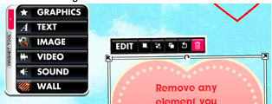

**Send image to Back**

**Bring Image to Front**

**Edit Button:** Upon clicking the **EDIT** button, the tool bar changes to this:

editbarglog

The first button after OK changes the color of a graphic. The second button inserts a hyperlink. The third button enables **TEXT EDITING.** The fourth button adds **EFFECTS** to an image, graphic, or text, such as a shadow or transparency. Click OK after editing to return to the previous tool bar.

**Hyperlinks:** You may add a hyperlink to text by using the **“link”** button. Click the “**Edit**” button, click the **“Link”** button and type the URL in the box. Click **“OK.”** To add a hyperlink to images, select the image by clicking on it. Click the “**Edit**” button. Then, click the “**Link**” button. Type in the URL and click “**Okay**.”



**Hyperlink Button**

**Video:** Add a video (such as *YouTube*) from the web. Select the **VIDEO** tool and select either “**UPLOAD**” or “**LINK**.” Choose “**UPLOAD**” to browse for a video. If the video is on the web, click “**LINK.**” Type or paste the URL for the video into the blank. Click **“ADD TO YOUR FILES”** and the video will be added. (Videos cannot be watched in the **edit mode**.)

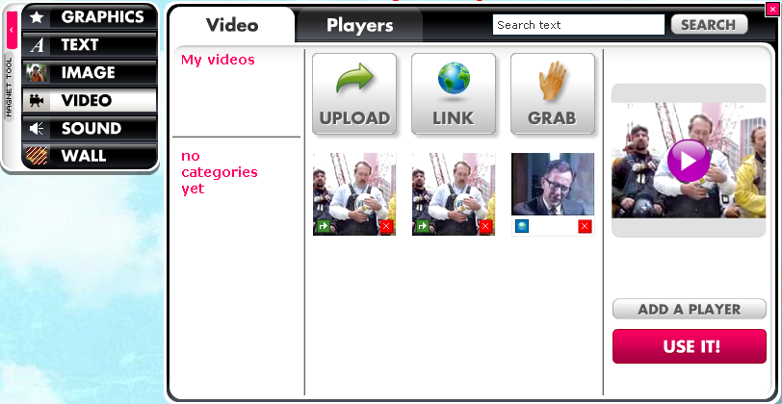

Add a **PLAYER** to your video clip by selecting the **Player tab,** choosing a player, then selecting ADD PLAYER. If you click on the player, and then the EDIT box for the player, this tool bar will appear:

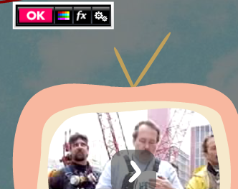

**Use this if you want to set your video player to play automatically when the Glog is opened.**

**Sound or Music Files:** Insert same as Video files. An **AUTOPLAY button** is available for music files by clicking on the EDIT button for the audio player and selecting the AUTOPLAY feature.

**Saving Your Glog:** save your Glog by using the “**SAVE AND PUBLISH**” button at the top

or bottom of the screen.



The next screen will appear.

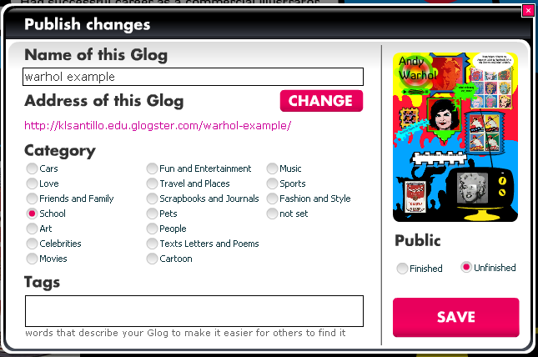

Double‐check that your glog has a meaningful name. If not, give it a unique name. Under **“Category”**, check categories as appropriate. **You can click on “Unfinished” until you have finished your glog and want others to see it; edu glogs can be viewed in draft form by the teacher.** Click **SAVE.**

**Embedding/Linking Your Glog**

After clicking the save button, the below dialog box will appear allowing you to link, share or embed your glog. If you intend to embed your glog in a blog or wiki you will want to grab the code from here rather than your dashboard in order to get the smaller version placed on the page. Then provide a link to the full version using the link option here.

1. **Embed**: To embed a small version in your wiki and then add a link, grab the link from here. Click on ***Edit*** and then ***Save & Publish*** to get the version of the embed code that embeds a smaller version of your glog. Copy the code in that box. Return to the webpage where you would like to paste it. Open the edit window and paste it according to the directions for that site.
2. **Link**: simply copy the link location and paste it wherever you want it to go.

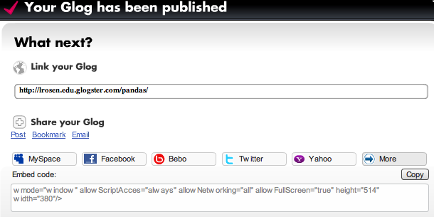

**Editing Your Glog:** once your glog has been saved, you may want to edit it or link it in a wiki, blog or course site.



1. Click on **“My dashboard”** at the top of your screen.
2. Scroll towards the bottom and on the left you will see the glogs in your account.

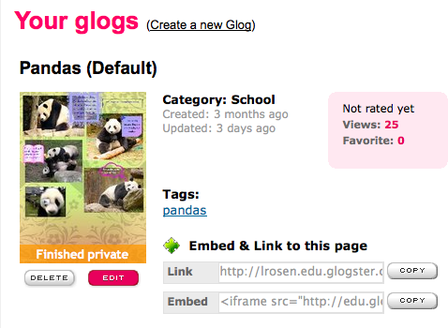

1. From here you have a host of options:
   1. **Edit**: Click edit to make changes or additions to your blog. This will automatically update any versions of that glog which are already embedded elsewhere.
   2. **Delete**: If you were just doing a practice glog and you no longer want it, delete it here.
   3. **Embed**: this embed code will embed a full size version of your glog. Some of the media may be cut off depending on the set up of the website in which it is to be embedded. See previous embed options for a smaller version.