HUMANS OF NEW YORK
MONDAY OCTOBER 5 2015

For context on the upcoming story, it is important to understand the ‘plastic boat.’ The plastic boat is a central figure in the story of almost every refugee coming to Europe via Turkey. Every day, thousands of people arrive to the Greek islands on these boats. They represent one of the only ways that refugees can bypass immigration restrictions and throw themselves at the feet of Europe. The journey is extremely dangerous and many have drowned in the past few months. Despite paying Turkish smugglers $1500 per person, the refugees are loaded into boats that are filled to many times their capacity. The boats usually leave at night to avoid detection. Often the refugees arrive carrying nothing but horror stories. Unfortunately there is little waiting for them on the other side. If they are lucky, a handful of volunteers will meet them on the beach with a bottle of water. In Lesvos, where this photo was taken, the refugees will then begin a 50-mile walk to the port where they can register. The UNHCRand several NGOs are scrambling to provide bare necessities, but their resources are stretched to capacity. They can offer little beyond a guarantee of survival. The initial elation of the refugees at having reached Europe will quickly subside as many realize they cannot even afford the price of a ferry to get off the island.

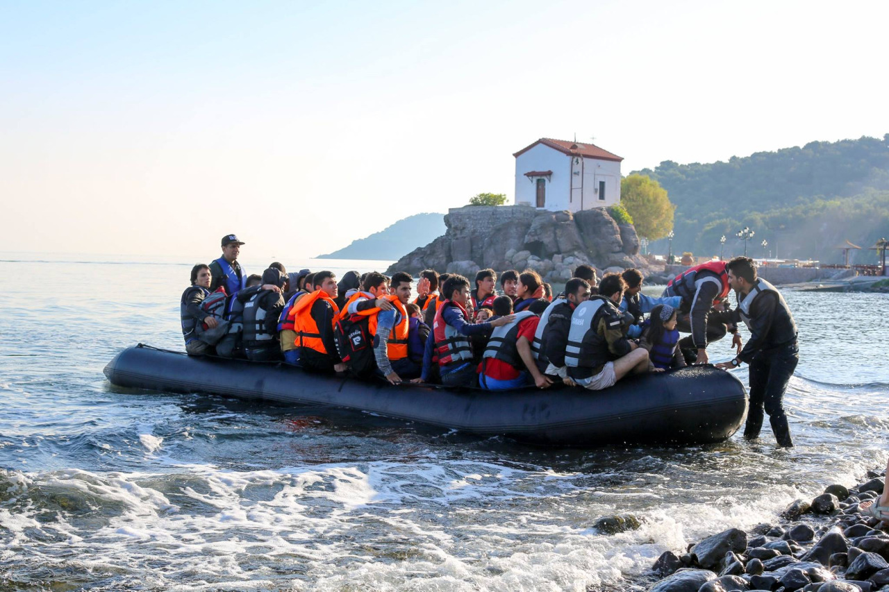

- OVER
My husband and I sold everything we had to afford the journey. We worked 15 hours a day in Turkey until we had enough money to leave. The smuggler put 152 of us on a boat. Once we saw the boat, many of us wanted to go back, but he told us that anyone who turned back would not get a refund. We had no choice. Both the lower compartment and the deck were filled with people. Waves began to come into the boat so the captain told everyone to throw their baggage into the sea. In the ocean we hit a rock, but the captain told us not to worry. Water began to come into the boat, but again he told us not to worry. We were in the lower compartment and it began to fill with water. It was too tight to move. Everyone began to scream. We were the last ones to get out alive. My husband pulled me out of the window. In the ocean, he took off his life jacket and gave it to a woman. We swam for as long as possible. After several hours he told me he that he was too tired to swim and that he was going to float on his back and rest. It was so dark we could not see. The waves were high. I could hear him calling me but he got further and further away. Eventually a boat found me. They never found my husband.” (Kos, Greece)

