Name: __________________________________________ Date: ________________________ Block: _______
Memoir Notes
Definitions
Memoir: A collection of memories that an individual writes about moments or events, both public or private, that took place in the subject's life.
Autobiography: An account of a person’s entire life, written by that person.
Remember: Vignette: A short, impressionistic scene that focuses on one moment or gives a sharp and detailed impression about a character, idea, setting, or object.
Six Word Memoir
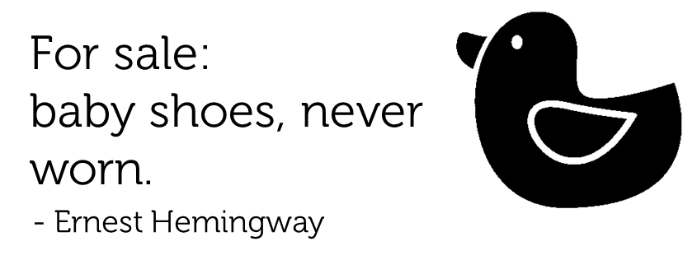

Challenged to tell the story of his life in six words, that is what famous author Ernest Hemingway responded. In 2006, a magazine hosted a contest for the best six word memoirs, and the trend caught on quickly. People began to submit millions of memoirs, inspired by the idea of how powerfully just a few words can tell your story.

Tips:
- Choose powerful moments in your life.
- Choose six compelling words – don’t use words you don’t need.
- Try not to just list six separate words – you want a complete phrase.
- Use punctuation to your advantage. How can you use punctuation to cut down your words?
- Choose a theme: life lessons/love/school/hobbies/losses/beliefs/humor/etc.


 
 
 
 
 
 

