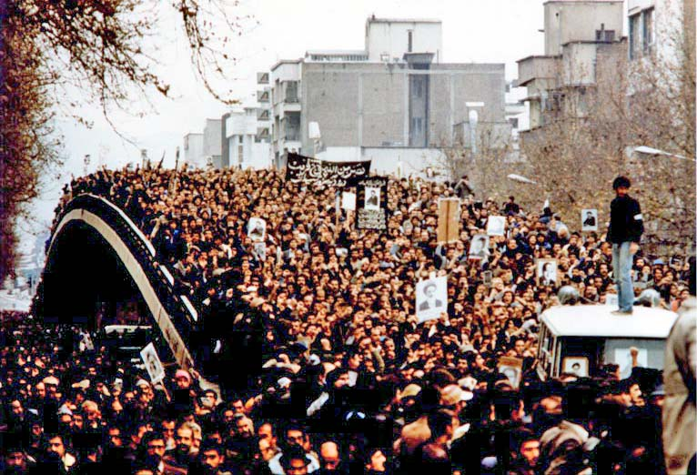
Photo taken during the Iranian Revolution, 1979

