Setting up your World Literature Blog/Portfolio
Follow these simple instructions in order to create your Weebly website for this class.
- Go to www.weebly.com

- Sign up for free: Enter your full name (first and last), your email address*, and a password. (*If you don’t have an email address, please go to www.gmail.com and create one for free. I suggest that your email address reflects your name and the professionalism that you need as you are a young adult.)

- When you see this screen, choose BLOG:
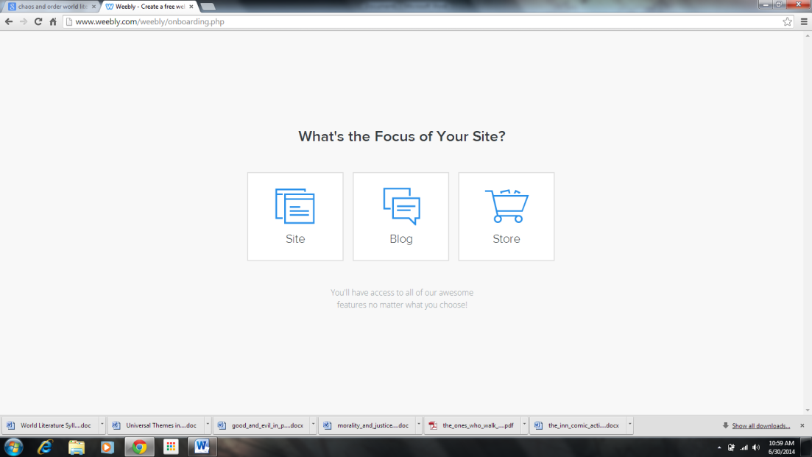

- Choose a theme for your site. If you hover over the bottom of each choice, it will show you colors. *Hint: Don’t spend all your time here right now. You can always go back and make it look good.

- When you get to this screen, choose the top option. Please make your subdomain name something that I can easily recognize as YOU. No slang, crazy nicknames, or anything else. For example, use your first name and last initial, your first initial and last name, or your full name. Type it in and continue.

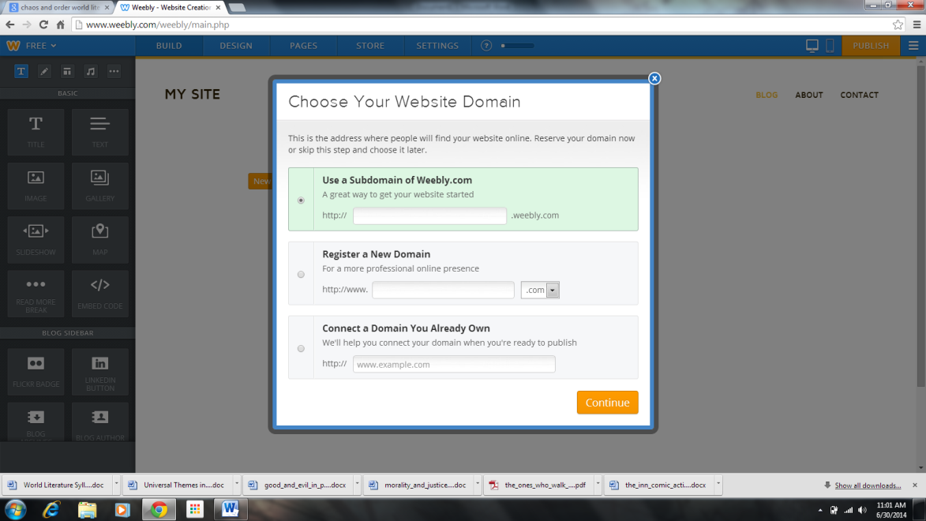

- That will bring you to this page, which is your landing ground anytime you go to work on your blog:
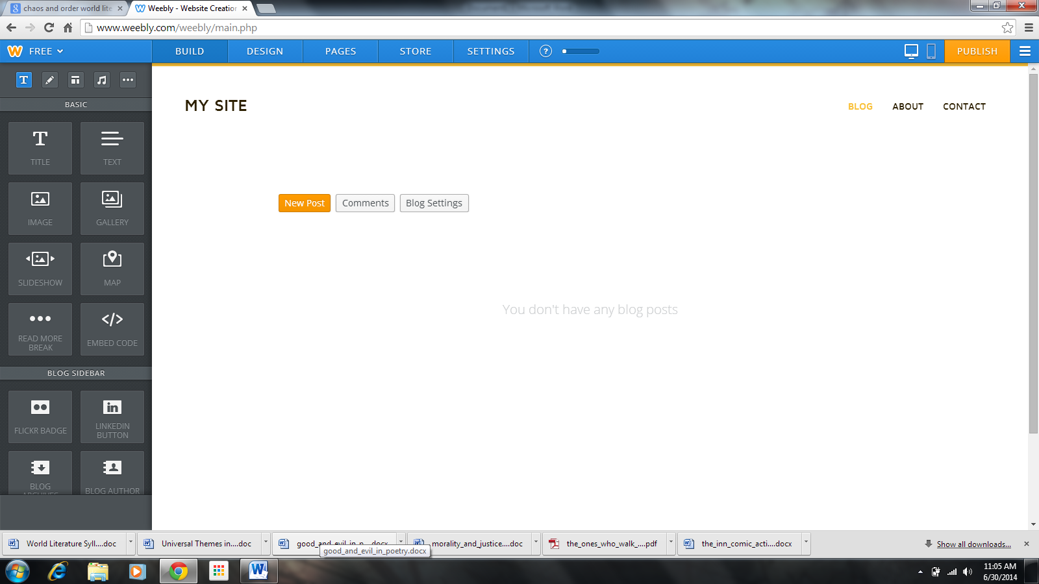

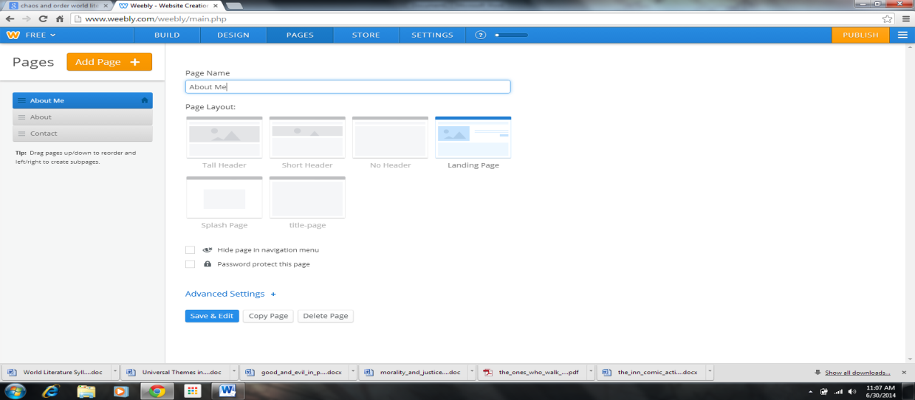
- First, click on PAGES (3rd from the left on the top taskbar). You will need to create multiple pages for your site. Do this before you do anything else. Make your first page a LANDING PAGE, and please title it ABOUT ME. *Hint: If it doesn’t let you choose STANDARD or BLOG page, you may have to delete the page and recreate it, make it a STANDARD PAGE, and drag it to the top.

- Your second page should say UNIT 1, and please choose NO HEADER. Again, you might have to actually add a page in order to check. It needs to be a BLOG PAGE.
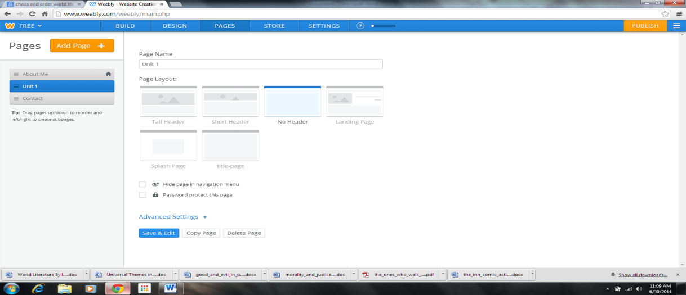

- Your third page should say UNIT 2, and please choose NO HEADER. Again, you might have to actually add a page in order to check. It needs to be a BLOG PAGE.
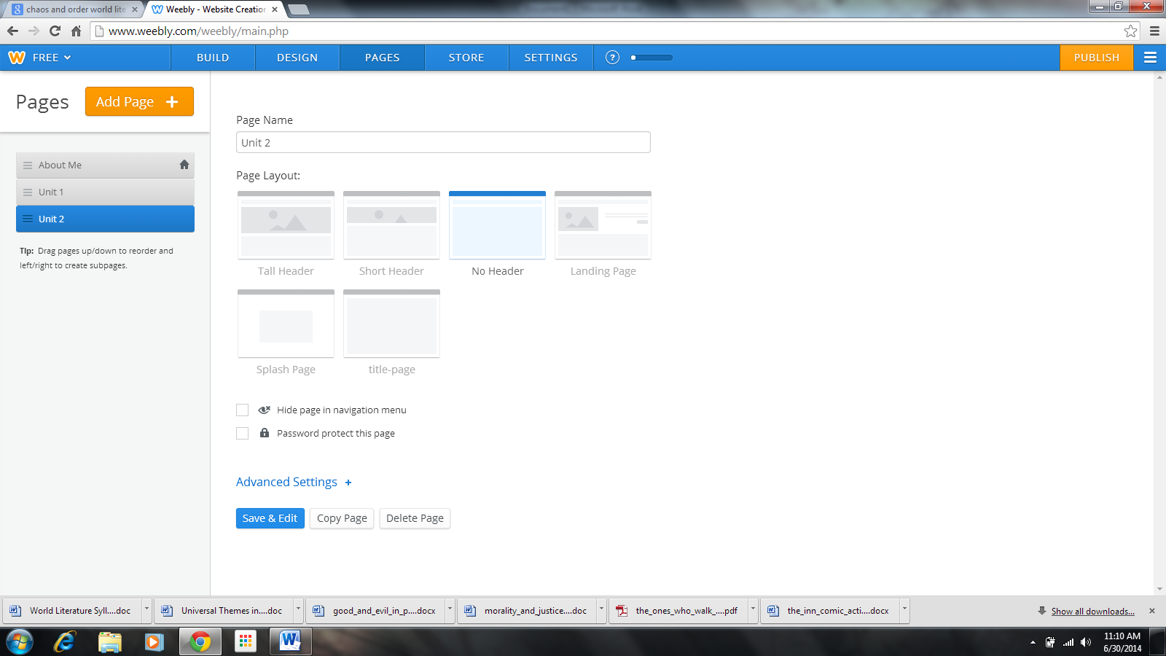
- Now, you need to click on the orange button that says ADD PAGE. Add a BLOG PAGE. Name it Unit 3, and choose NO HEADER.
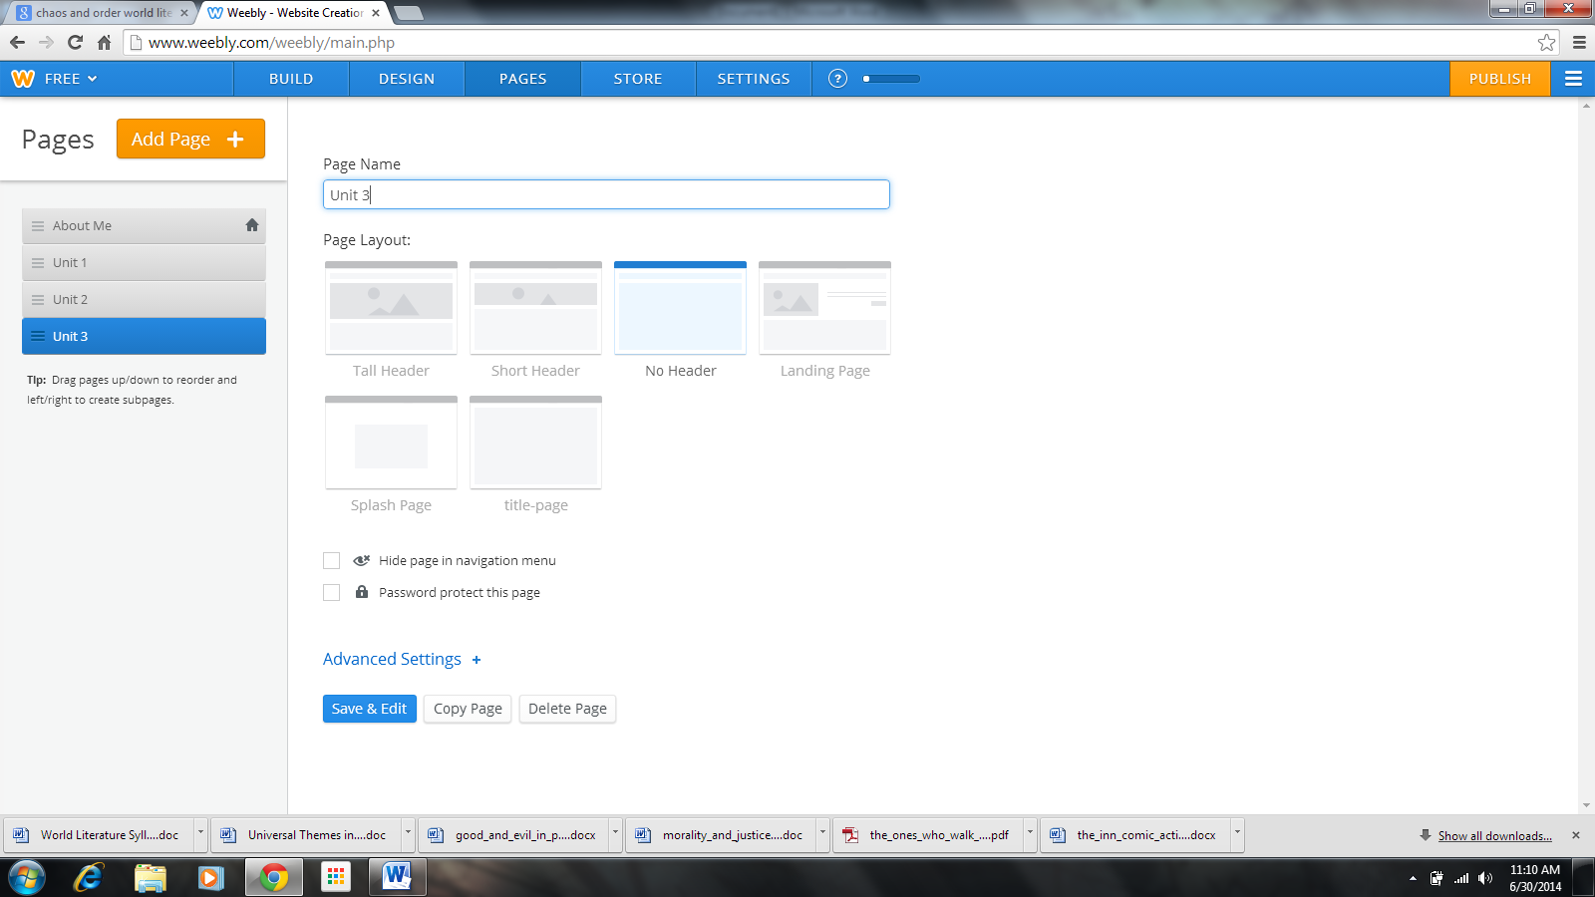
- One more time: ADD PAGE, add a BLOG PAGE. Name it Unit 4, and choose NO HEADER. I’m going to skip the screenshot this time. I think you understand!

- Last time: ADD PAGE, add a STANDARD PAGE. Name it Final, and choose NO HEADER. Then, click the blue button that says SAVE & EDIT.

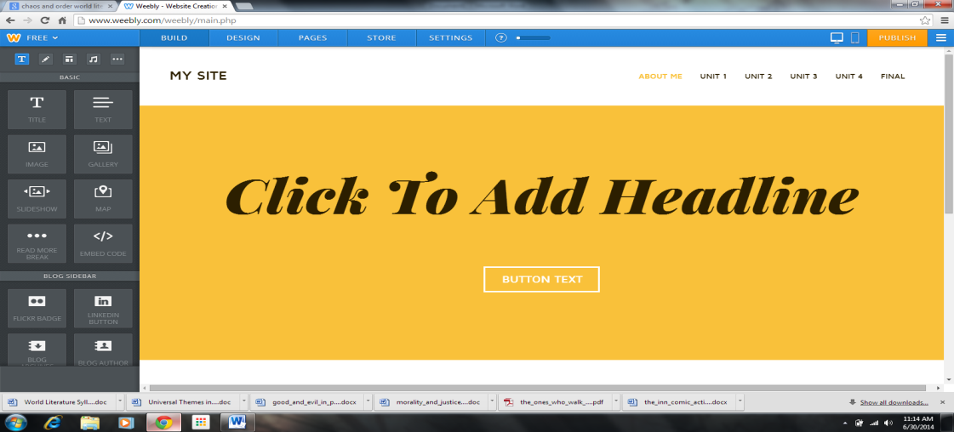
- That should take you to your home page, which is the page you’ll see when you access your website. Here’s mine:

- From here on out, you may spend your time customizing your page. Obviously, the best way to learn is by experimenting. Here is a rough guide to the functions of each button in the control panel on the left. **These are the functions I think you should use/may want to use as you design your website. Many of them are only available to you with the paid upgrade, and many of them have no purpose on a site you’re using for this class. However, feel free to look around and discover what you may.

- Title: Adds a title in larger, bolder lettering.
- Text: Drops a text box (you can have multiple per page). This is where you will add your written information/pieces of writing.
- Image: Drops photo boxes (you can have multiple per page). You will have to upload photos and save them to your computer in order to upload them to your site.
- Gallery: Allows you to upload multiple photos that will display in a row.
- Slideshow: Allows you to upload a photo slideshow.
- Divider: Drops a divider line into your page.
- Spacer: Creates white space between two elements of your page.
- Button: Drops a button you can use to link to a different page on your site that quickly forwards your reader there.
- Document: Drops an embedded document into your site that your reader can view just by looking at the page.
- YouTube: Embeds a YouTube video onto your page.
- File: Allows you to upload documents that your reader opens by clicking on the link.
- Block Quote: Pulls out one quote and makes it larger and bolder.
- Poll: Allows you to set up a question and poll/vote on your site.
*In order to customize/change your colors or theme, click on Design (2nd from left on top taskbar).
- Your About Me/Landing Page should include the following information/elements:
- Your Name
- World Literature Blog/Portfolio (or give it a personal title if you want to get creative!)
- Photo(s)/Picture(s)/Artwork of you and/or representing you (*must be school appropriate!)
- Six Word Memoir
- Quote/Song Lyric/Saying that you live by/strongly believe in (*must be school appropriate!)
- Favorite Book, Movie & Hobby OR 3 interesting facts about you

- Once you are satisfied with your blog, click the orange button in the top right corner that says PUBLISH. Double check your domain name. Make sure it’s spelled correctly, professional, etc.

- Congratulations! Your website is live. Now, last step:
- Go to my blog: yeglit.weebly.com
- Click on Student Blogs
- Find your class period’s entry.
- Submit your full name and link to your blog as a comment.

