World Literature Encyclopedia
Language Project

To show your mastery of World Literature vocabulary, you will be creating a personal encyclopedia of the terms and concepts from this class. This is one more way to show what you have learned this semester (and what you still have to learn in Unit 4). We will work on it over the next few weeks. Ultimately, your book is due on Friday, December 12.

What is an encyclopedia?
- A reference work that compiles, alphabetically, topics from many branches of knowledge.

What goes in an encyclopedia?
- Encyclopedia entries are longer and more detailed than those in most dictionaries.
- Encyclopedia articles focus on factual information about the term or concept.
- The articles typically include background information, an explanation of the importance of the topic, and images.

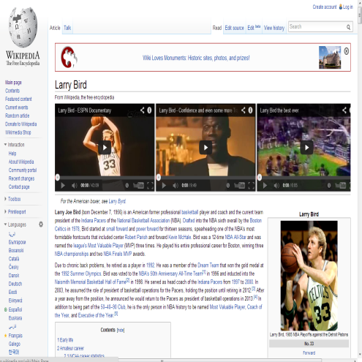
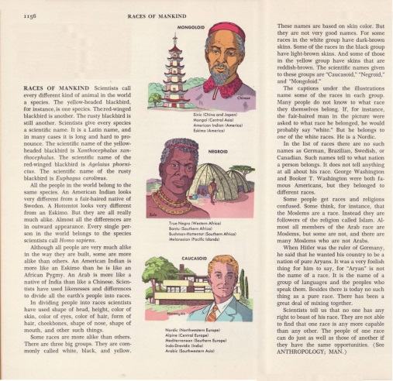
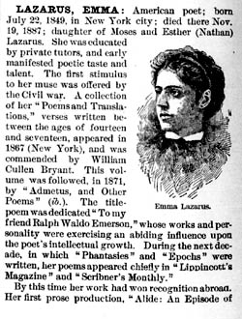

Requirements:
- Cover 25 letters of the alphabet (consider X/Y/Z one letter).
- Have at least 40 total entries (meaning you will have more than one entry for some letters of your choosing).
- Include the “non-negotiable words” discussed in class.
- Include for every entry:
1) The term/concept
2) A definition (if applicable)
3) At minimum, one short paragraph (4-6 sentences) giving the background information, explanation of why it’s important, what you learned about the term/concept, etc.
4) At least one image (drawn, printed, magazine, etc.) with a caption explaining the image’s relation to the topic.
- Bind your book.
- Turn it in on or before the due date.

World Literature Encyclopedia: Brainstorm Sheet
Letter | Term/Concept I Will Use (you may do more than one) | Image I Could Use
A
B
C
D
E
F
G
H
I
J
K
L
M
N
O
P
Q
R
S
T
U
V
W
X/Y/Z

